**Nama : Adelia Nanda Irviena**

**Kelas : 12.3B.13**

**NIM : 12200636**

**Tugas WEB PROGRAMMING II**

**Berikut hasil dari latihan pertemuan 6**

1. **Tampilan Database “Pustaka”**

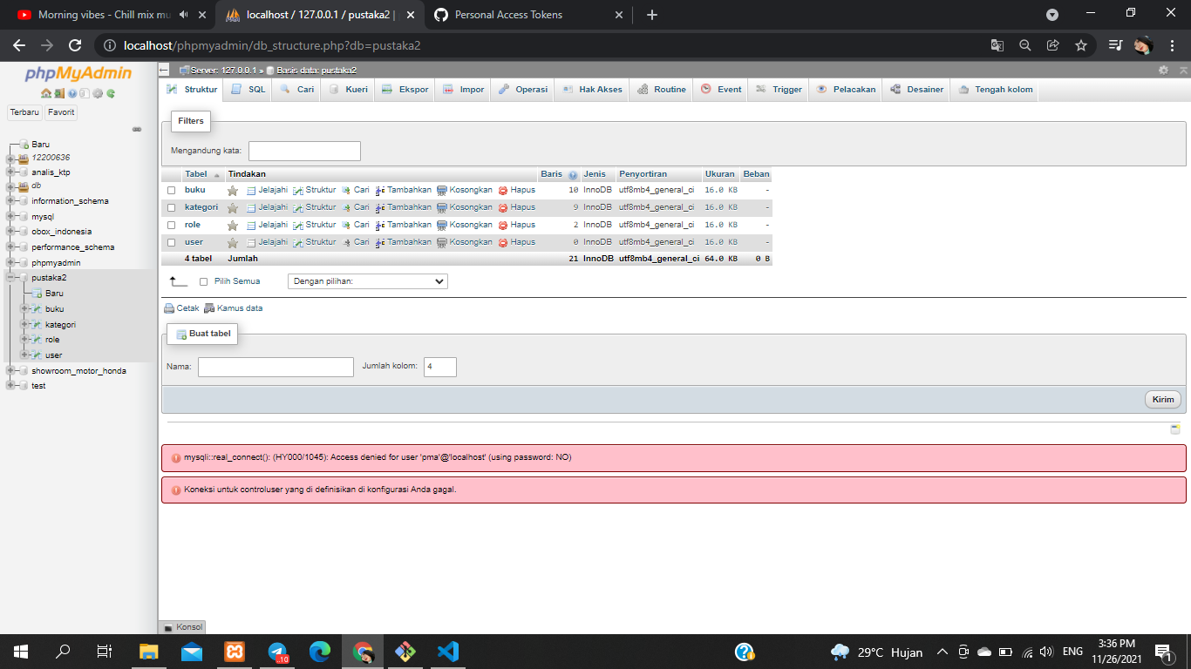

1. **Isi Tabel Buku**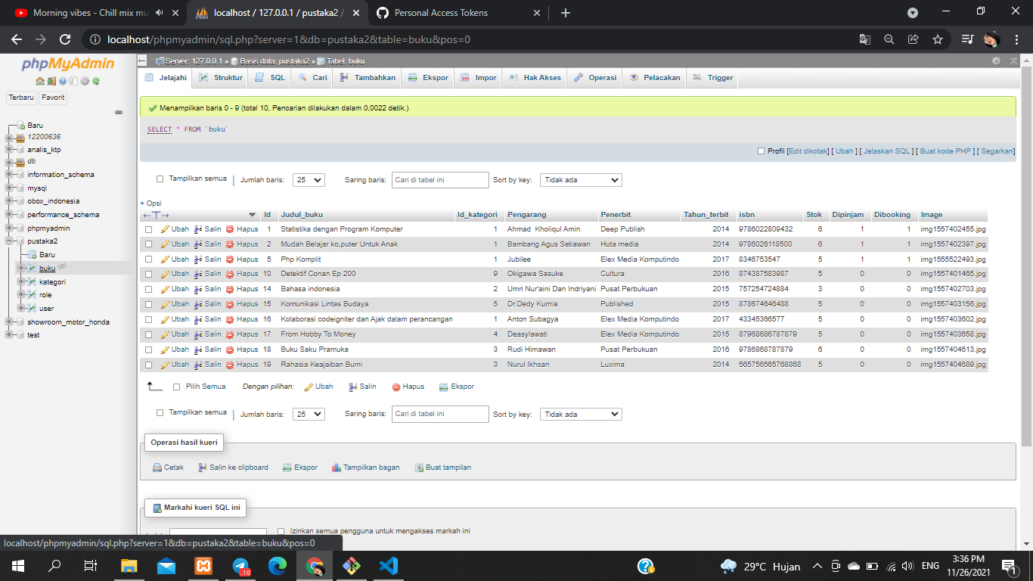
2. **Isi Table Kategori**

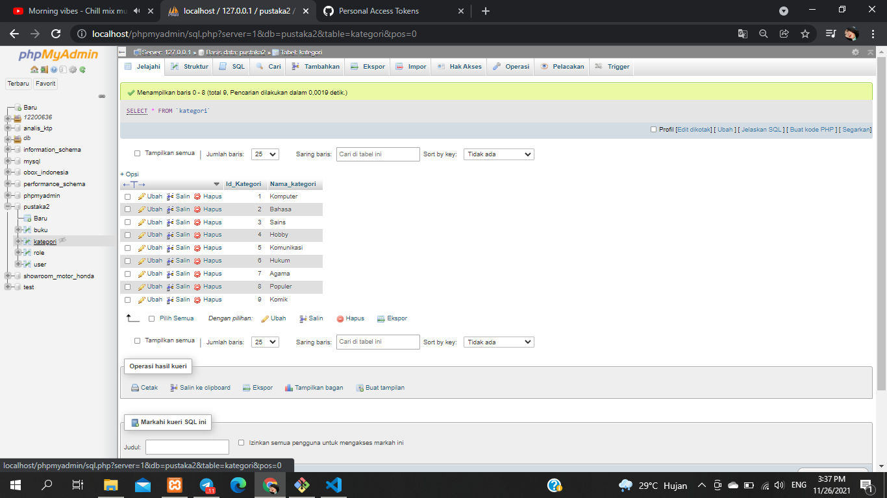

1. **Isi Table Role**

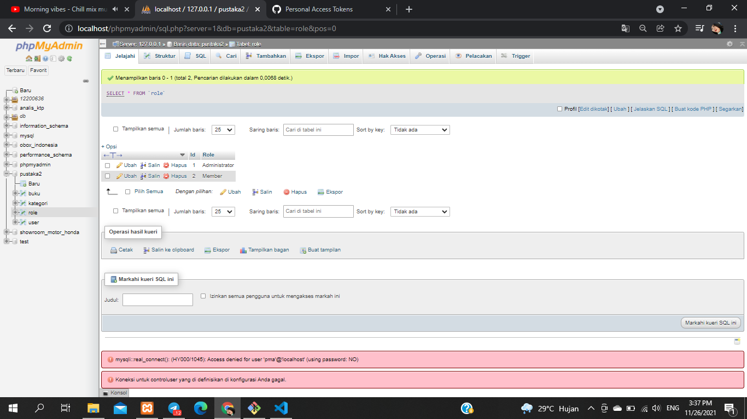

1. **Listing “Database.php”** 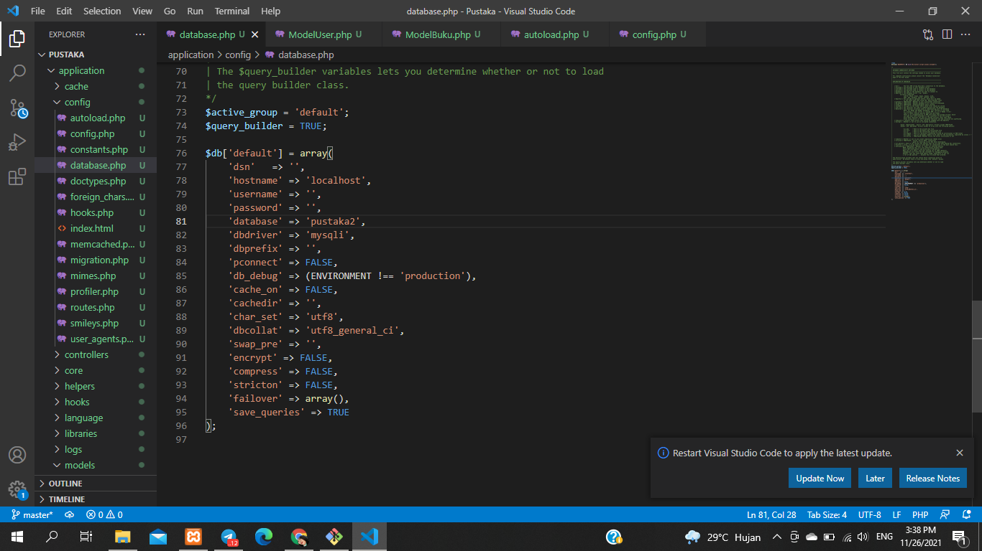
2. **Listing “ Autoload.php”**

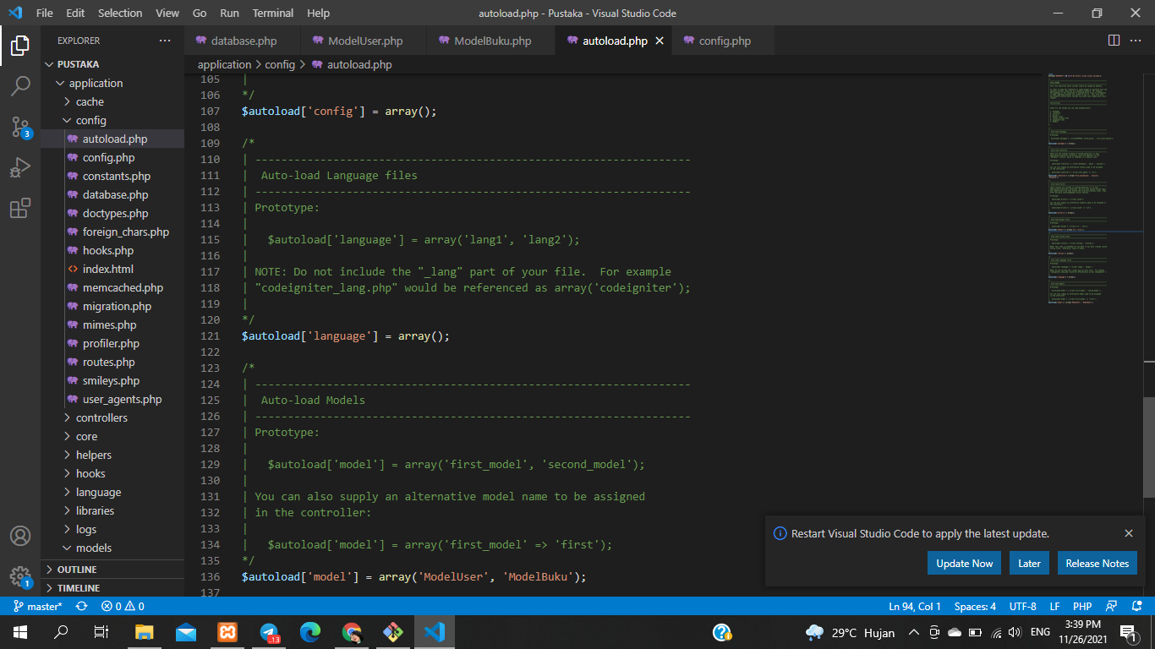

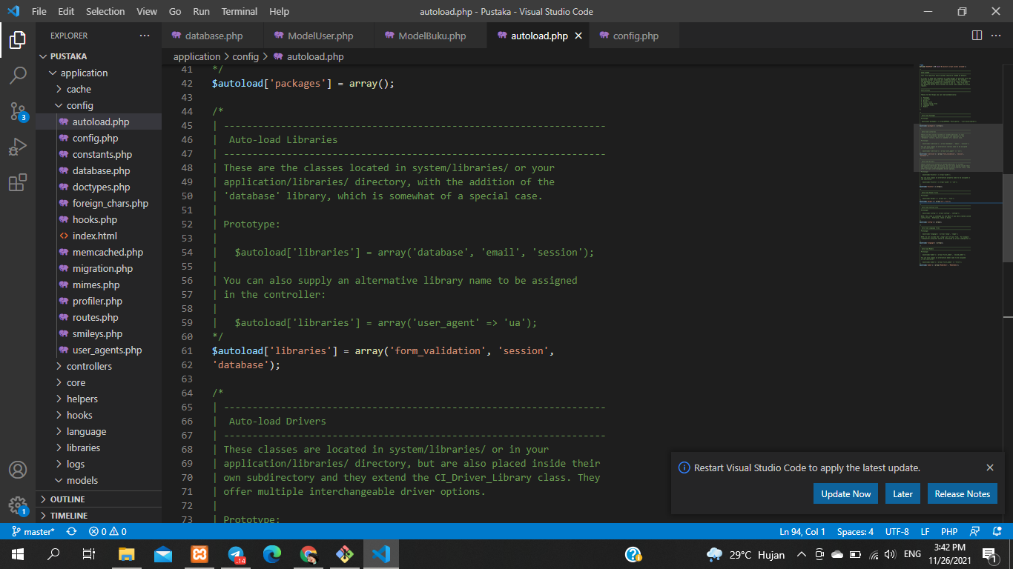

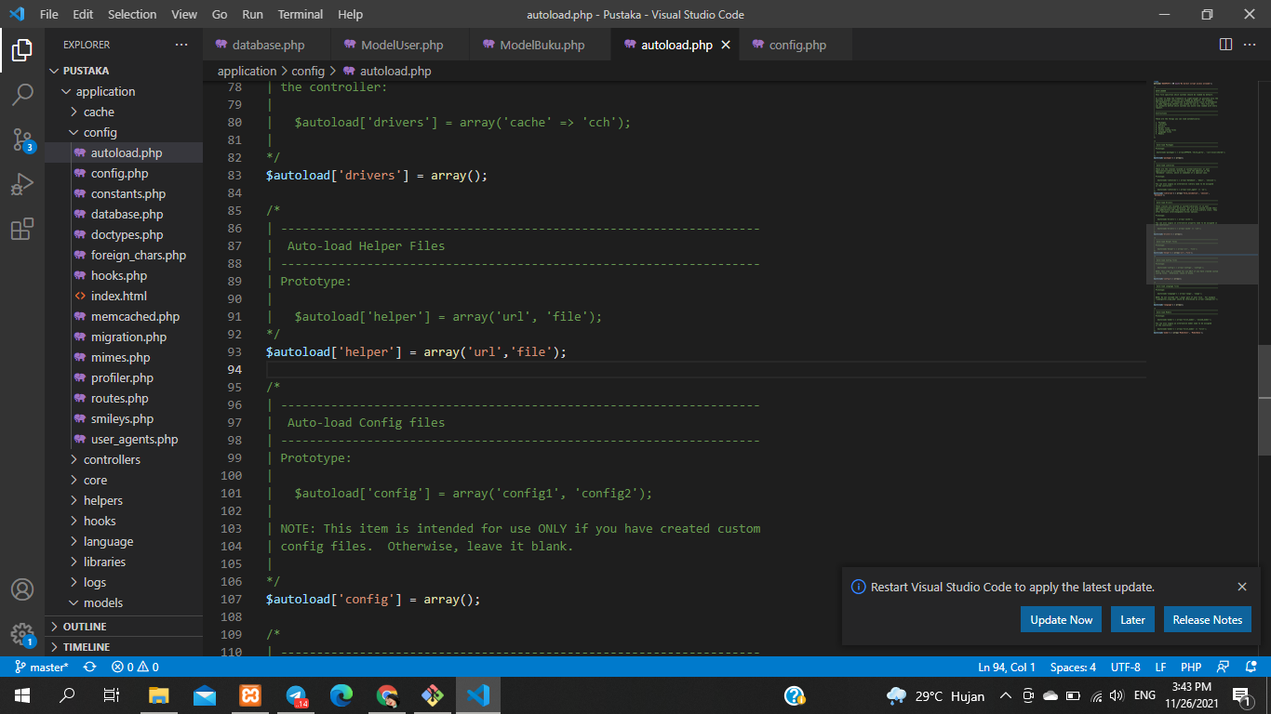

1. **Listing “config.php”**

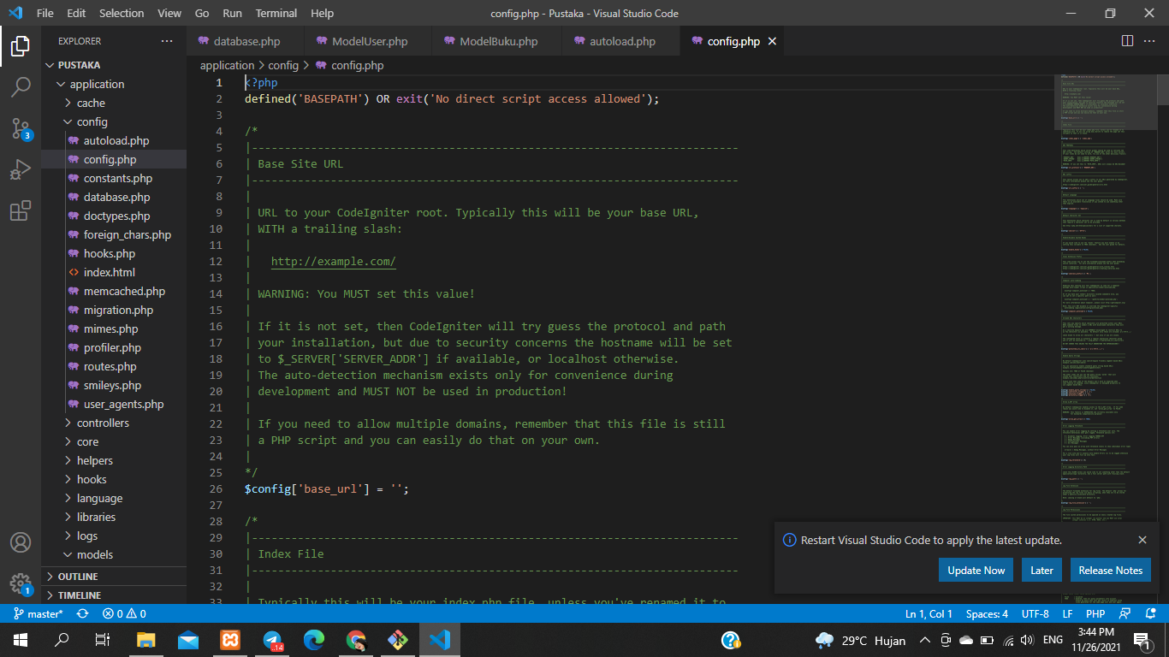

1. **Listing “ ModelBuku.php”**

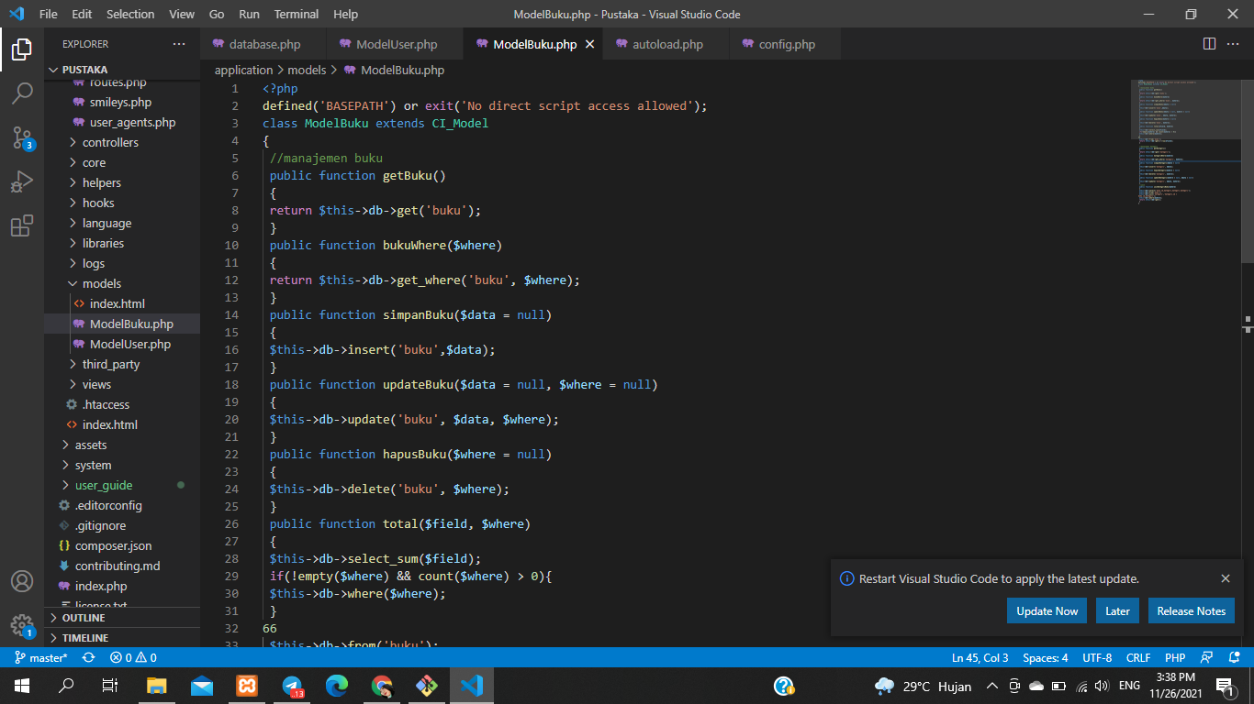

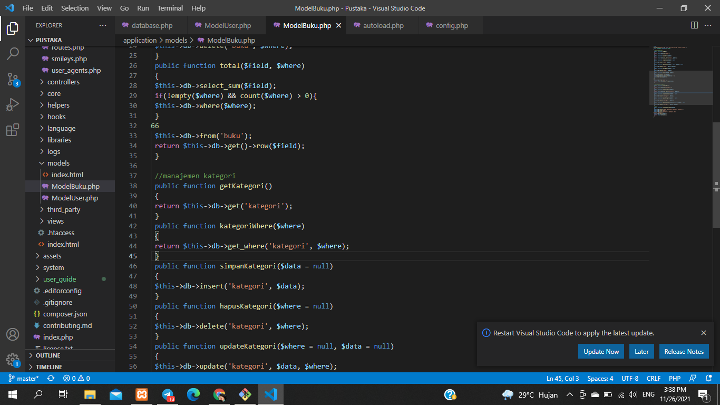

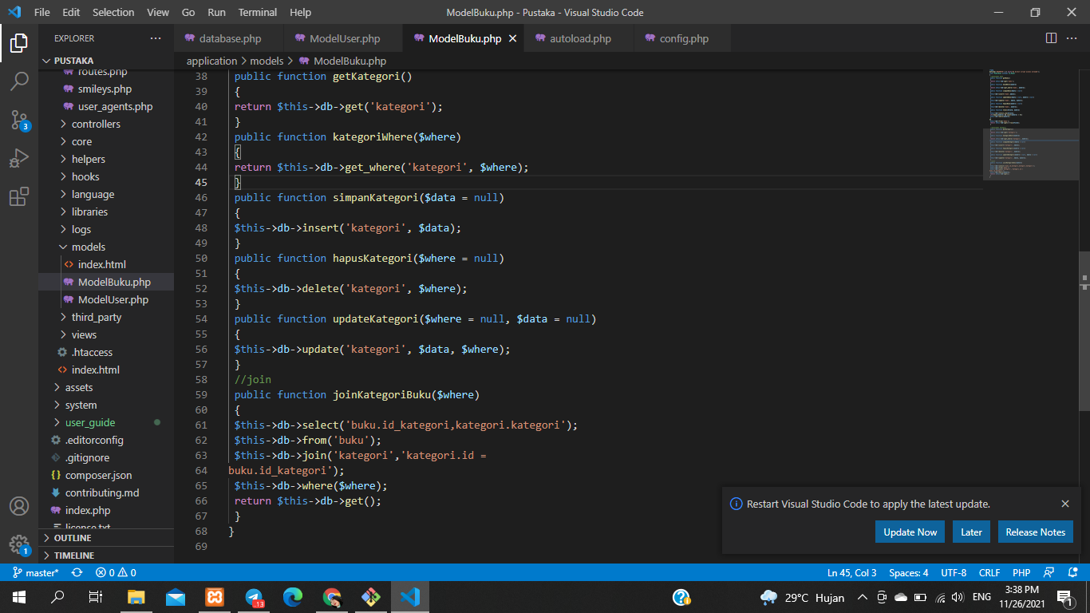

1. **Listing “ ModelUser.php”**

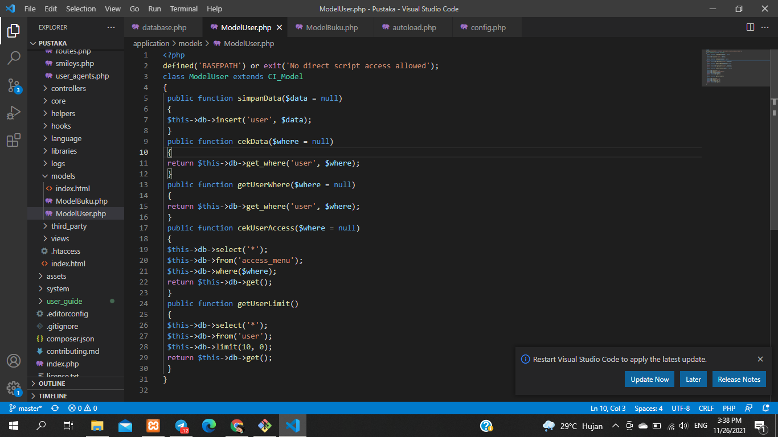

1. **File berhasil di push**

